Given an m x n matrix matrix and an integer k, return *the max sum of a rectangle in the matrix such that its sum is no larger than* k.

It is **guaranteed** that there will be a rectangle with a sum no larger than k.

**Example 1:**

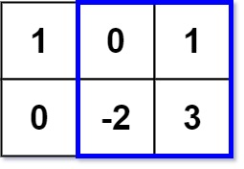

**Input:** matrix = [[1,0,1],[0,-2,3]], k = 2

**Output:** 2

**Explanation:** Because the sum of the blue rectangle [[0, 1], [-2, 3]] is 2, and 2 is the max number no larger than k (k = 2).

**Example 2:**

**Input:** matrix = [[2,2,-1]], k = 3

**Output:** 3

**Constraints:**

* m == matrix.length
* n == matrix[i].length
* 1 <= m, n <= 100
* -100 <= matrix[i][j] <= 100
* -105 <= k <= 105

**Follow up:** What if the number of rows is much larger than the number of columns?